**LAB ASSIGNMENT 8.1**

**NAME:TAHIYA MAHEROZE**

**ROLLNO:2403A52349**

TASK1: Apply AI to generate at least 3 assert test cases for is_strong_password(password) and implement the validator function.

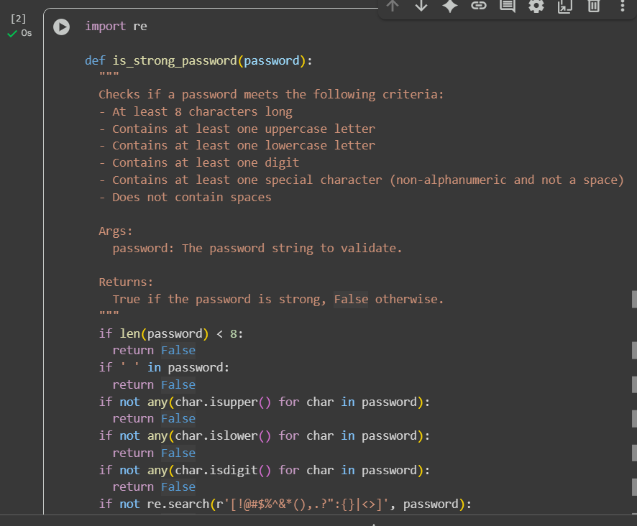

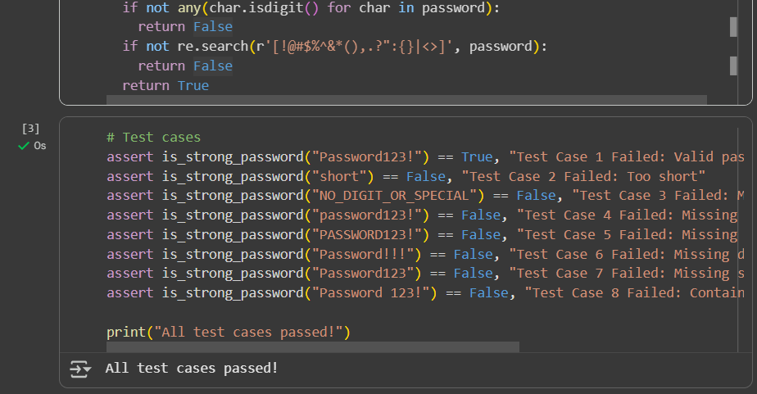

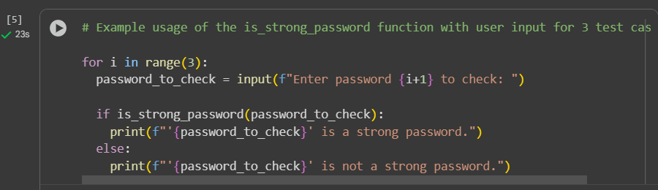

OUTPUT:

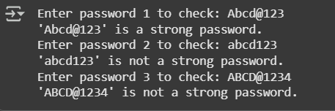

EXPLAINATION:

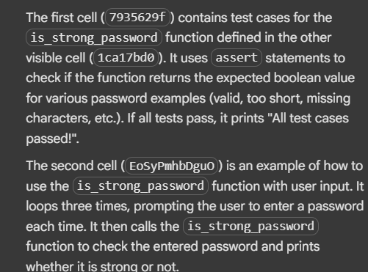

TASK2: write a python program to generate at least 3 assert test cases for a classify_number(n) function. Implement using loops it should o Classify numbers as Positive, Negative, or Zero and o Handle invalid inputs like strings and None and o Include boundary conditions (-1, 0, 1) and ask the user input for 3 test cases

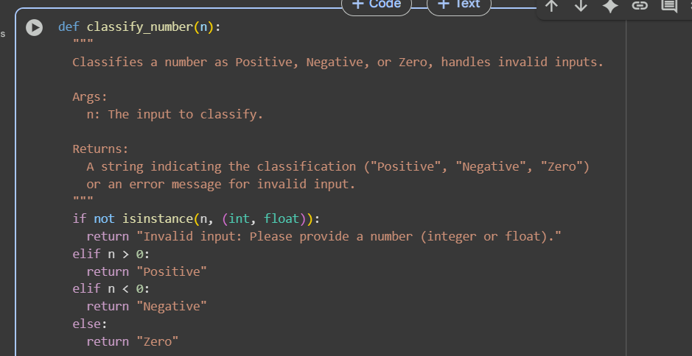

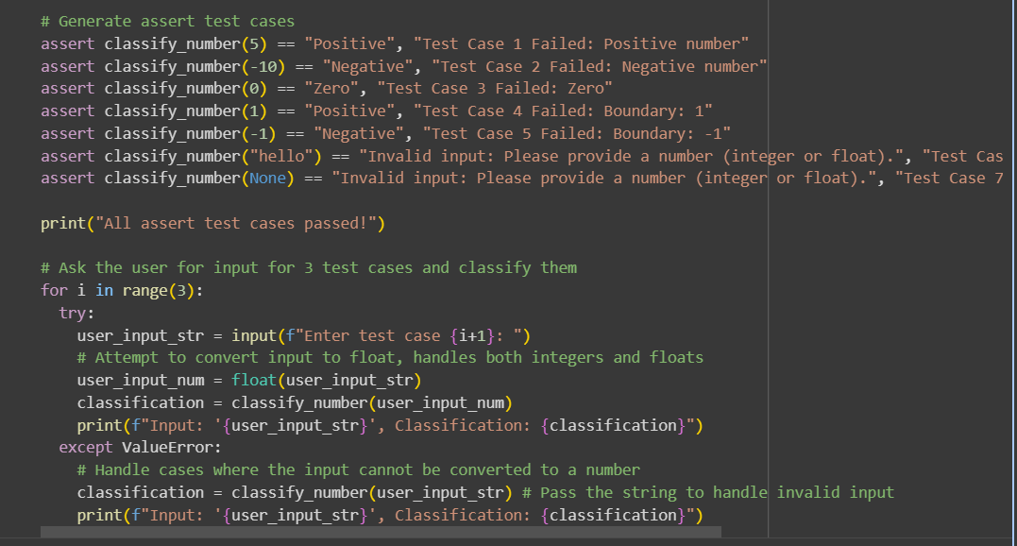

Output:

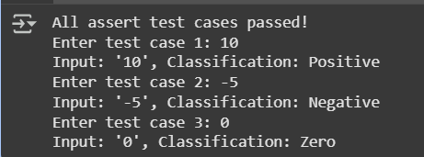

Explaination:

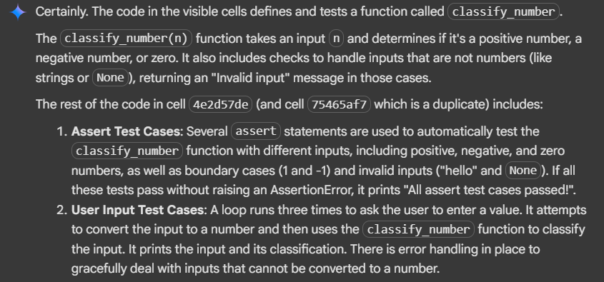

Task3: write a python program to generate at least 3 assert test cases for is_anagram(str1, str2) and implement the function that need to Ignore case, spaces, and punctuation and o Handle edge cases (empty strings, identical words) and also aske the user input for 3 test case

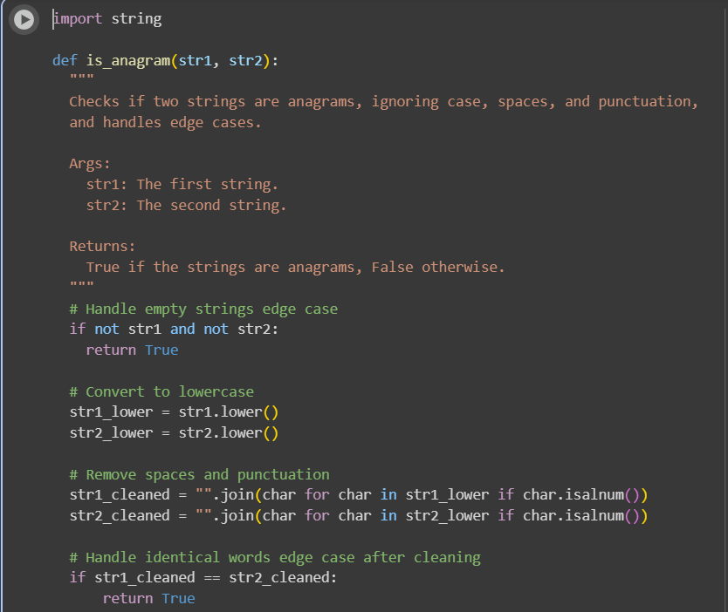

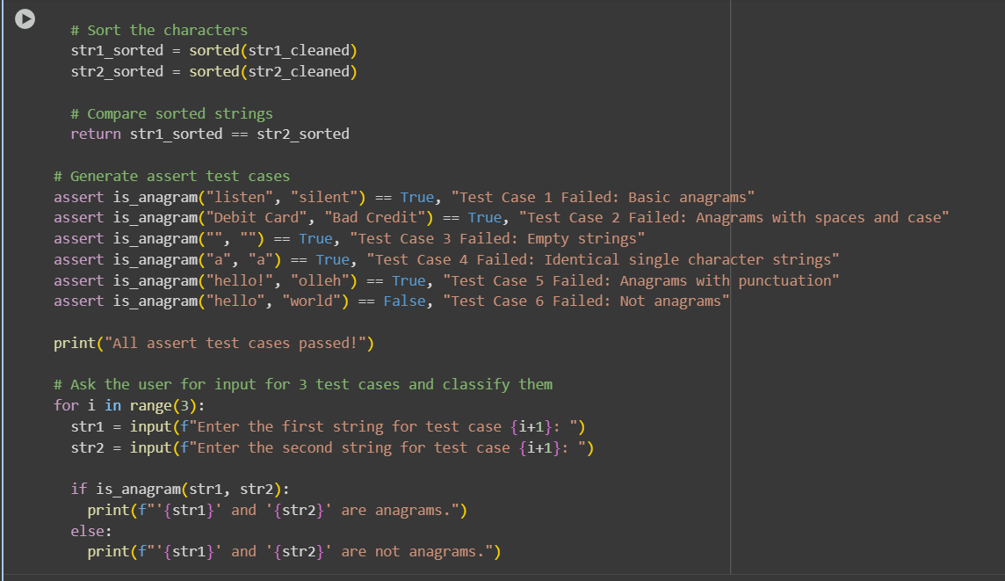

Output:

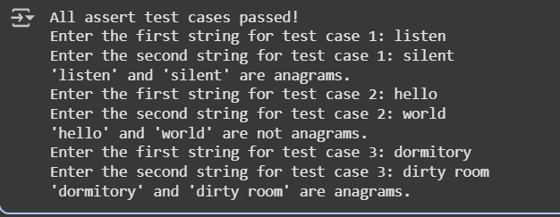

Explaination:

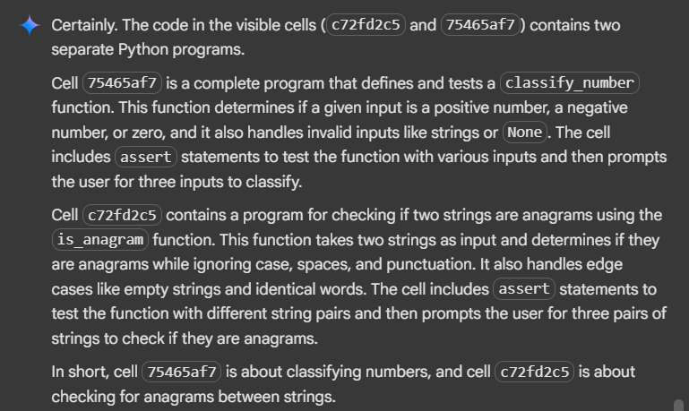

Task4: write a python program to generate at least 3 assert-based tests for an Inventory class with stock management with the methods o add_item(name, quantity) remove_item(name, quantity) get_stock(name) and ask the user input for 3 test cases

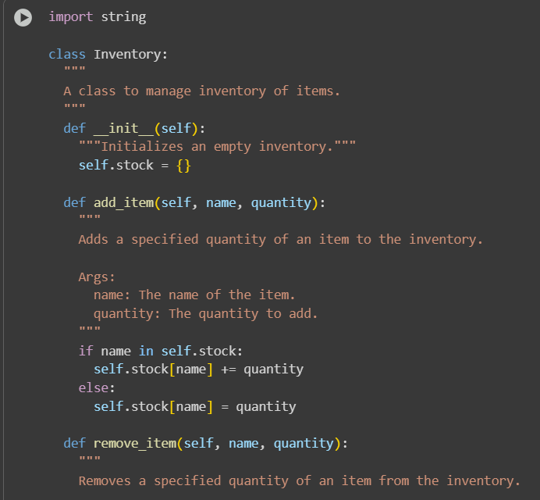

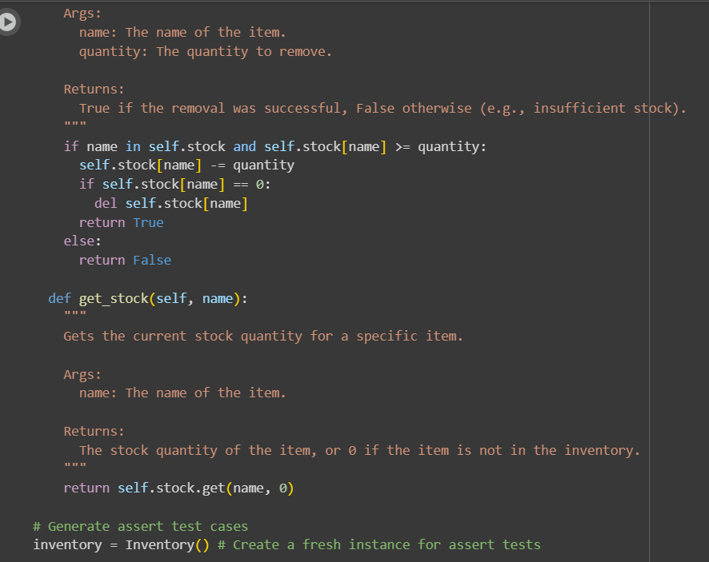

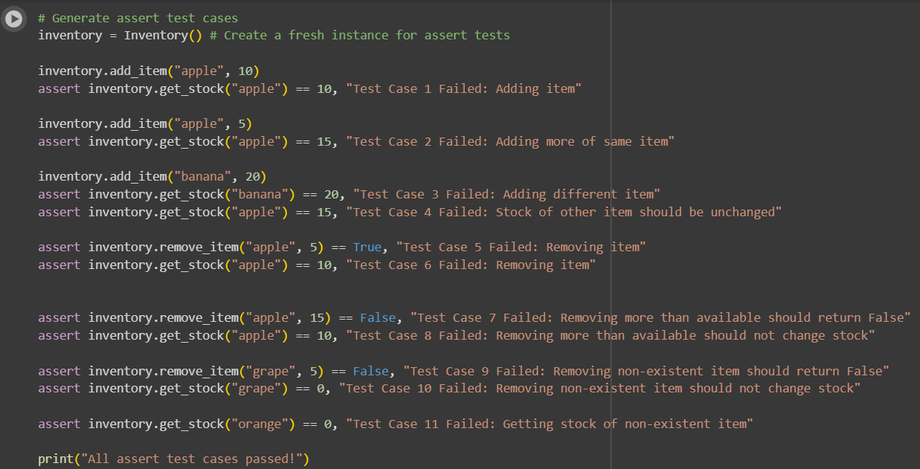

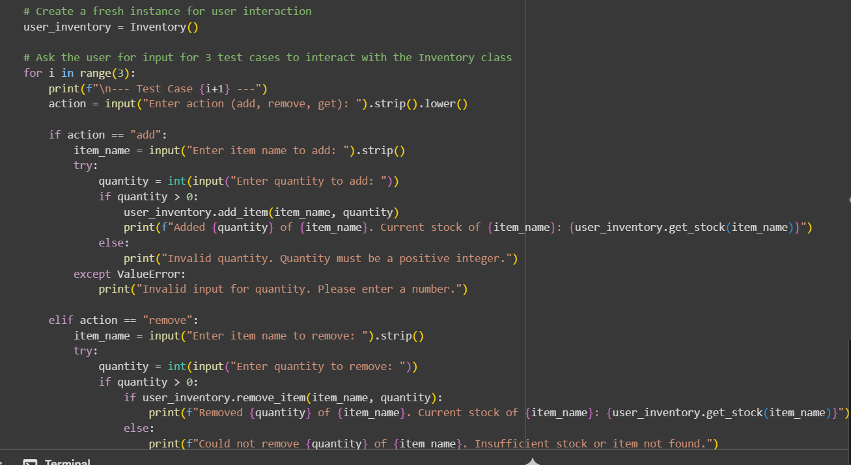

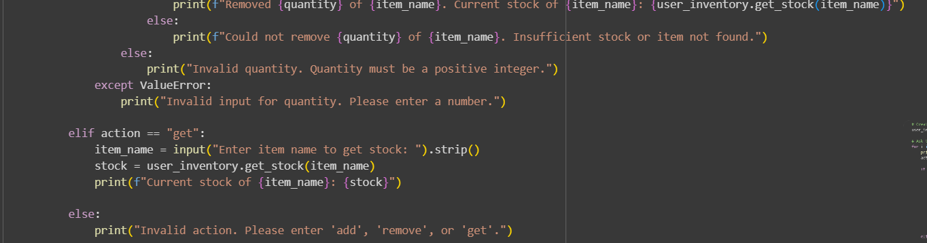

Output:

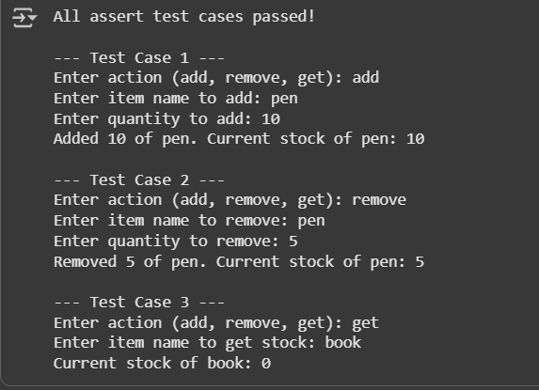

Explanation:

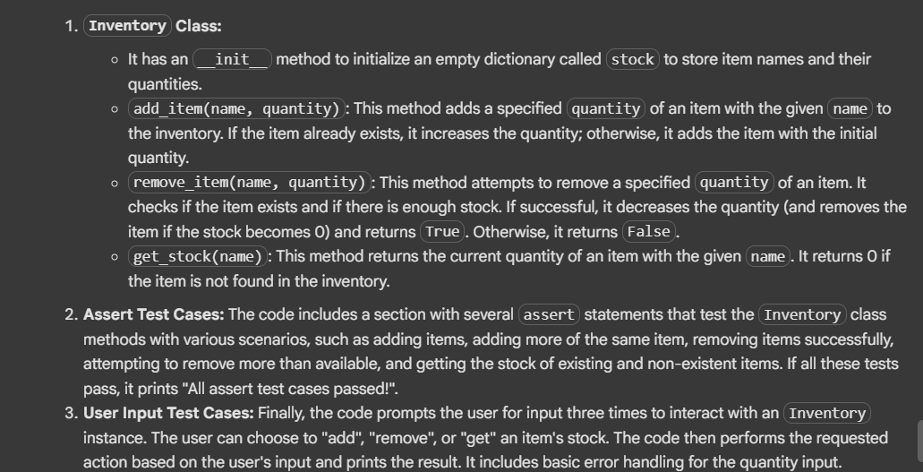

Task5: write a python program to generate at least 3 assert test cases for validate_and_format_date(date_str) to check and convert dates with o Validate "MM/DD/YYYY" format,Handle invalid dates,Convert valid dates to "YYYY-MM-DD" and ask the user input for 3 test cases

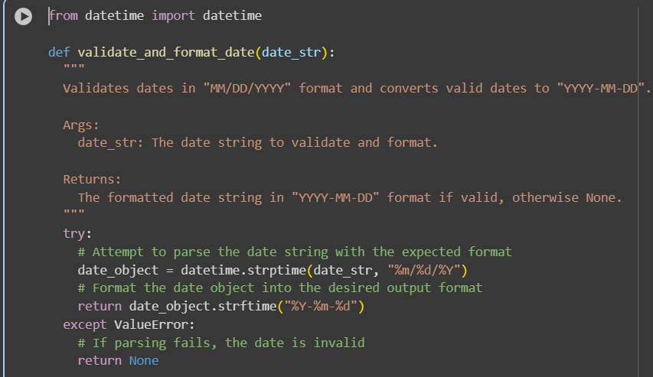

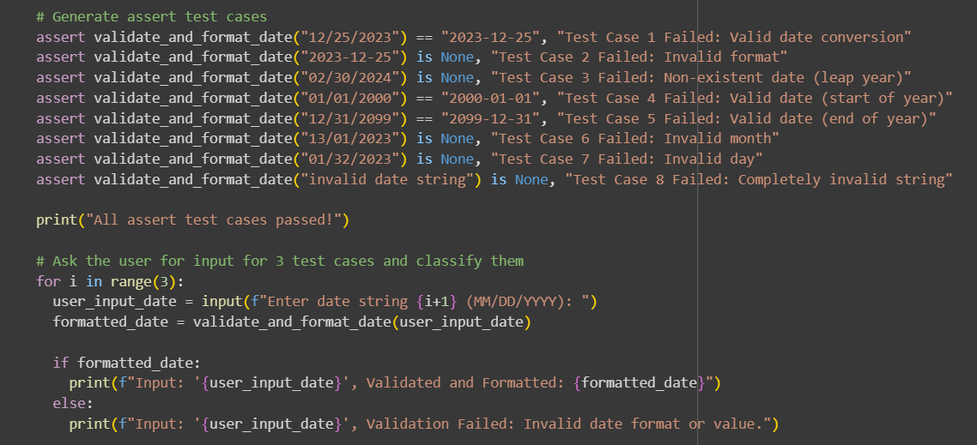

Output:

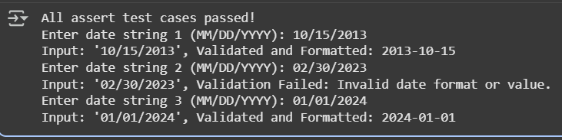

Explaination:

